British Airlines Passenger CSAT Dashboard
This dashboard analyzes British Airways customer satisfaction by evaluating ratings across aircraft types, services, travel segments, and time. It highlights key performance trends and helps identify areas for improving overall passenger experience.

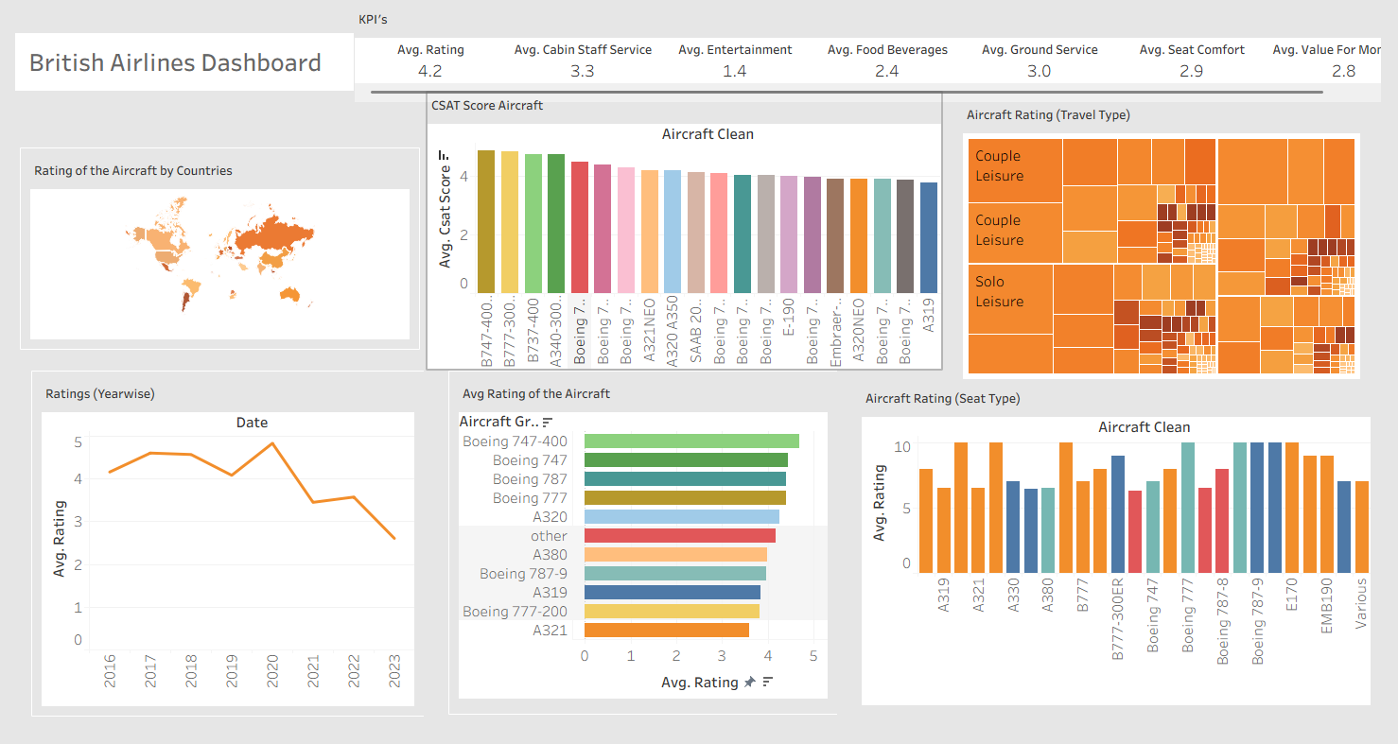

KPI Summary

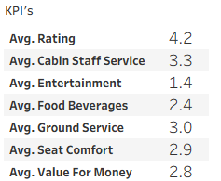

- Overall Avg Rating : 4.2 (moderate satisfaction)
- Cabin Staff Service : 3.3 (comparatively strong)
- Entertainment : 1.4 (weakest service area)
- Food and Beverages : 2.4 (below average)
- Ground Service : 3.0 (acceptable)
- Seat Comfort : 2.9 (average)
- Value for Money : 2.8 (customers expect better pricing value
Rating of the Aircrafts by Countries (Map)

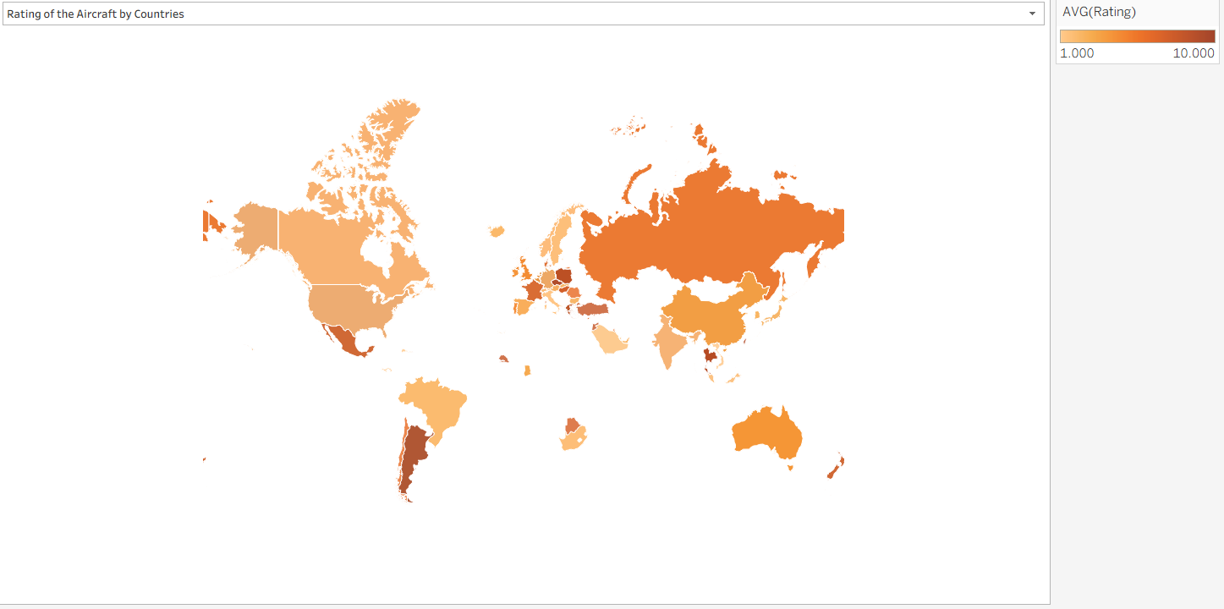
This map visualizes the average customer satisfaction (CSAT) ratings across different countries for British Airways aircraft.
- Customer ratings vary noticeably by geographic region, indicating uneven passenger experience worldwide.
- Higher ratings are observed in parts of Europe, Russia, Australia, and South America, suggesting stronger service performance or customer perception in these regions.
- Moderate ratings are seen across North America and parts of Asia, indicating acceptable but improvable experience.
- Some regions show lower average ratings, highlighting potential gaps in service consistency or regional operations.
Key Insight:
Passenger satisfaction differs by country, suggesting that regional service standards, operational efficiency, or route-specific factors play an important role in customer experience. Targeted regional improvements could help standardize service quality globally.

CSAT Score by Aircraft
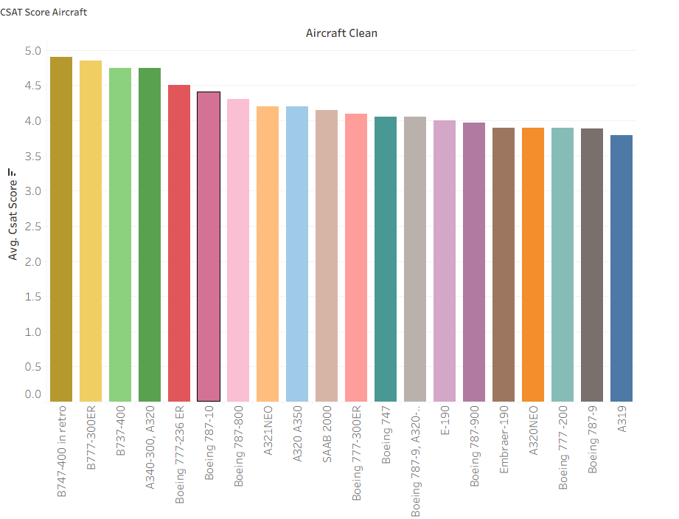

Overall Insight
- The average CSAT scores range roughly from 3.8 to 4.9, indicating generally positive customer satisfaction with aircraft cleanliness across the fleet.
- Most aircraft score above 4.0, which is a strong benchmark for cleanliness perception.

Top Performing Aircraft (Highest CSAT)
- B747-400 (in retro) – 4.9 (highest score)
- B777-300ER – 4.85
- B737-400 and A320 (older variants) – 4.7–4.8

Mid-Range Performers
- Boeing 777-236 ER
- Boeing 787-10 / 787-800
- A320 NEO / A350 / SAAB 2000
Key Insights : Newer aircraft models deliver better customer satisfaction. Wide-body and older retro-maintained aircraft tend to score higher, possibly due to better maintenance focus or refurbishment.

Aircraft Rating by Travel Type

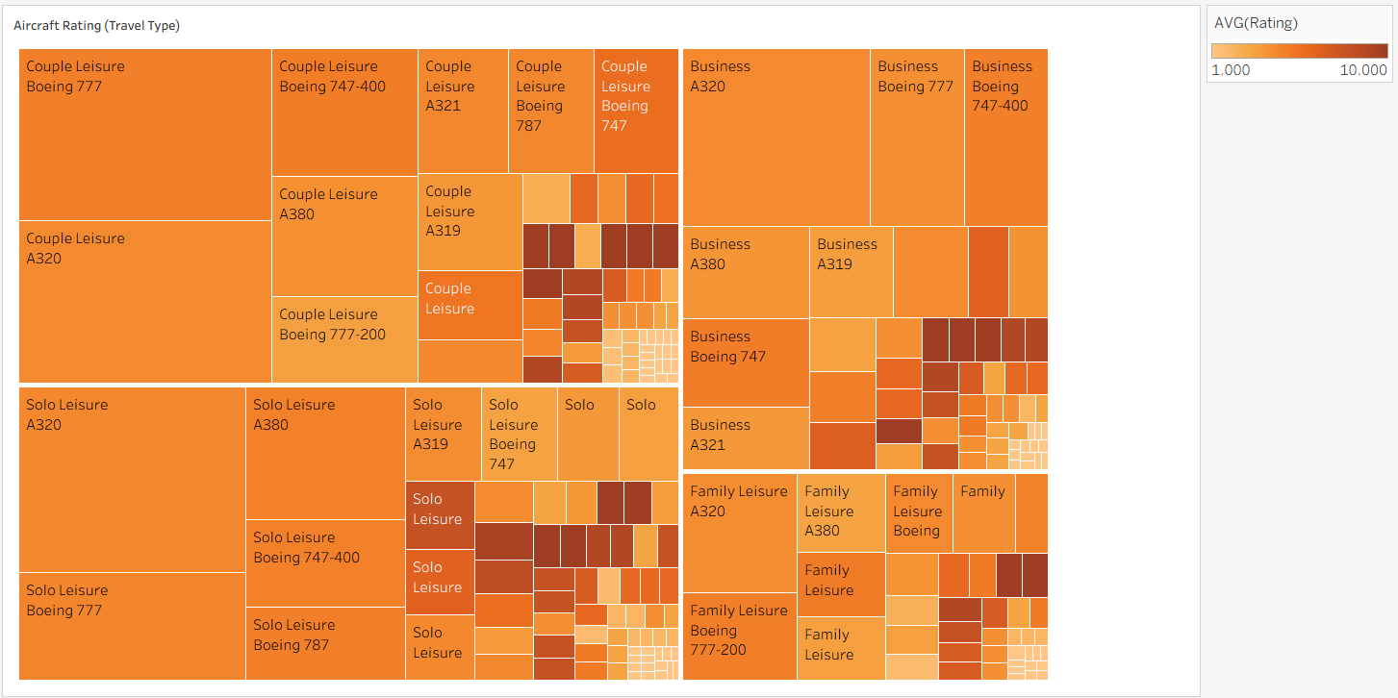
This treemap shows how customer satisfaction (CSAT) varies across aircraft types and travel segments (Business, Couple Leisure, Solo Leisure, Family Leisure).
- Business travelers generally give higher ratings, especially on wide-body aircraft like A320, A380, and Boeing 777, indicating better premium experience.
- Couple and Solo Leisure segments show mixed ratings, suggesting experience varies more by aircraft type.
- Family Leisure ratings are comparatively moderate, highlighting scope for improvement in comfort and onboard services for families.
- Larger aircraft tend to receive more consistent ratings across travel types.
Key Insight : Passenger satisfaction is influenced not just by aircraft, but by travel purpose. Tailoring onboard services by traveler segment can significantly improve overall CSAT.
Ratings Trend (Year-wise)
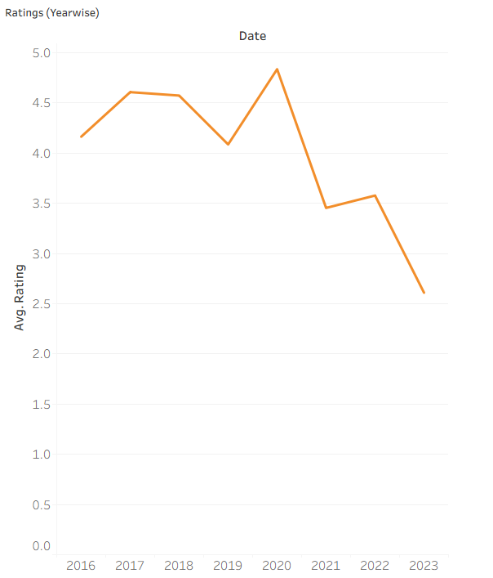

- Average ratings improved from 2016 to 2018, showing a positive customer experience trend.
- A dip in 2019 indicates a temporary decline in satisfaction.
- 2020 recorded the highest average rating, reflecting peak customer satisfaction.
- A sharp drop in 2021 suggests a major disruption impacting customer experience.
- Slight recovery in 2022, but ratings remained below pre-2020 levels.

Key Insights: External factors (post-pandemic operations, cost cutting) may have impacted service quality. Ratings improved until around 2020. Noticeable decline post-2020 through 2023.

Average Rating of the Aircraft

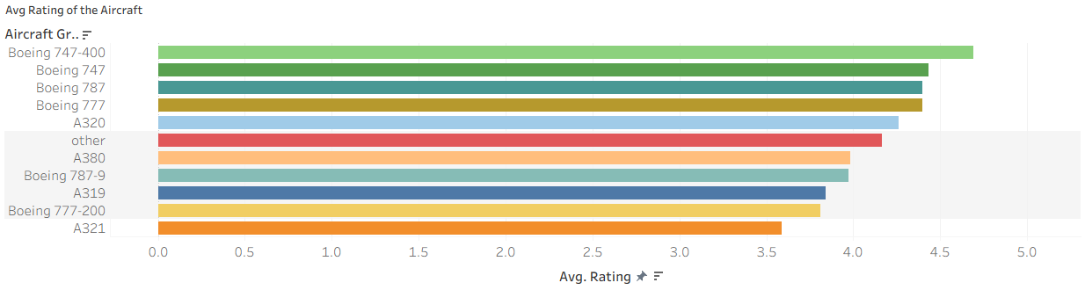

- Boeing 747-400 has the highest average rating, indicating strongest customer satisfaction.
- Boeing 747, Boeing 787, and Boeing 777 also perform very well, all scoring above 4.4.
- A320 sits in the upper-mid range, reflecting consistent but not top-tier ratings.
- The Other aircraft category shows moderately strong performance, around the 4.2 range.
- A380 and Boeing 787-9 receive solid but slightly lower ratings compared to top performers.
- A319 and Boeing 777-200 are among the lower-rated aircraft, suggesting scope for improvement.
- A321 has the lowest average rating, highlighting it as a key focus area for service or maintenance improvements.

Key Insights: Wide-body aircraft provide better passenger experience than narrow-body fleets. Best performing Boeing 747-400, Boeing 747, Boeing 787.

Aircraft Rating by Seat Type

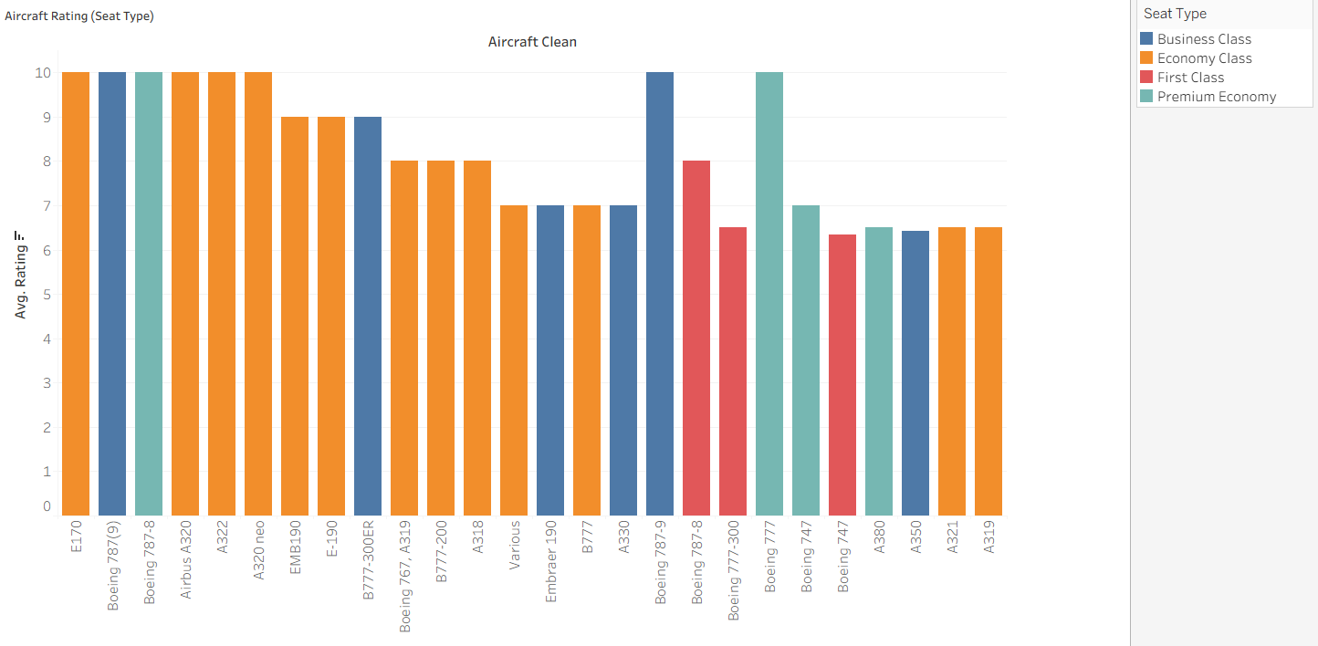

- Business Class and Premium Economy consistently receive the highest cleanliness ratings, often close to the top scale.
- Economy Class shows good but slightly lower ratings, indicating more variability in cleanliness perception.
- First Class ratings are strong overall but show some inconsistency across aircraft types.
- Aircraft such as Boeing 787, A320, A322, and A321 perform well across multiple seat types.
- Wide-body aircraft (B777, B787, A350) tend to score higher in premium seat categories.
- Narrow-body aircraft (A319, A320 variants) show comparatively lower ratings in Economy Class.
- Overall, seat type plays a significant role in perceived cleanliness, with premium cabins outperforming economy.

Overall Summary
The British Airways Passenger CSAT Dashboard highlights that overall customer satisfaction is moderate, with strong performance in cabin staff service and aircraft cleanliness, while entertainment, food & beverages, and value for money remain key improvement areas. Customer satisfaction is consistently higher for newer and wide-body aircraft, premium seat classes, and leisure travel segments. Year-wise trends show improving ratings up to 2020, followed by a noticeable decline post-pandemic. Overall, the analysis suggests that fleet modernization, service enhancements, and targeted improvements in weaker service areas can significantly improve passenger experience.

